UNITED STATES
SECURITIES AND EXCHANGE COMMISSION
WASHINGTON, D.C. 20549

FORM 8-K

CURRENT REPORT
PURSUANT TO SECTION 13 OR 15(d)
OF THE SECURITIES EXCHANGE ACT OF 1934
Date of Report (Date of earliest event reported): August 9, 2023

Vahanna Tech Edge Acquisition I Corp.
(Exact name of registrant as specified in its charter)

British Virgin Islands |  | 001-41094 |  | 98-1600102
(State or Other Jurisdiction  of Incorporation) |  | (Commission  File Number) |  | (IRS Employer  Identification No.)

1230 Avenue of the Americas
New York, NY 10020
(Address of principal executive office) (zip code)
Registrant’s telephone number, including area code: (347) 745-6448
N/A
(Former name or former address, if changed since last report)

Check the appropriate box below if the Form 8-K filing is intended to simultaneously satisfy the filing obligation of the registrant under any of the following provisions (see General Instruction A.2. below):

☒ | Written communications pursuant to Rule 425 under the Securities Act (17 CFR 230.425)

☐ | Soliciting material pursuant to Rule 14a-12 under the Exchange Act (17 CFR 240.14a-12)

☐ | Pre-commencement communications pursuant to Rule 14d-2(b) under the Exchange Act (17 CFR 240.14d-2(b))

☐ | Pre-commencement communications pursuant to Rule 13e-4(c) under the Exchange Act (17 CFR 240.13e-4(c))
Securities registered pursuant to Section 12(b) of the Act:

Title of each class |  | Trading  Symbol(s) |  | Name of each exchange  on which registered
Units, each consisting of one Class A ordinary share and one-half of one redeemable warrant |  | VHNAU |  | The Nasdaq Stock Market LLC
Class A ordinary shares, par value $0.0001 per share |  | VHNA |  | The Nasdaq Stock Market LLC
Redeemable warrants, each whole warrant exercisable for one Class A ordinary share, each at an exercise price of $11.50 per share |  | VHNAW |  | The Nasdaq Stock Market LLC
Indicate by check mark whether the registrant is an emerging growth company as defined in Rule 405 of the Securities Act of 1933 (§230.405 of this chapter) or Rule 12b-2 of the Securities Exchange Act of 1934 (§240.12b-2 of this chapter).
Emerging growth company ☒
If an emerging growth company, indicate by check mark if the registrant has elected not to use the extended transition period for complying with any new or revised financial accounting standards provided pursuant to Section 13(a) of the Exchange Act. ☐

Item 7.01 | Regulation FD Disclosure
Attached as Exhibit 99.1 hereto and incorporated herein by reference is an investor presentation dated August 2023, that will be used by Vahanna Tech Edge Acquisition I Corp. (“Vahanna”) in meetings with certain investors with respect to its proposed business combination (the “Business Combination”) with Roadzen, Inc., a Delaware corporation (“Roadzen”). In connection with the consummation of the Business Combination, Vahanna will be renamed “Roadzen Inc.” (“New Roadzen”). The investor presentation updates and supersedes the investor presentation furnished as an exhibit to Vahanna’s Form 8-K filed on July 10, 2023.
The information in this Item 7.01, including Exhibit 99.1, is furnished and shall not be deemed “filed” for purposes of Section 18 of the Securities Exchange Act of 1934, as amended (the “Exchange Act”), or otherwise subject to liabilities under that section, and shall not be deemed to be incorporated by reference into the filings of Vahanna under the Securities Act of 1933, as amended (the “Securities Act”), or the Exchange Act, regardless of any general incorporation language in such filings. This Current Report on Form 8-K will not be deemed an admission as to the materiality of any information of the information in this Item 7.01, including Exhibit 99.1.
Important Information About the Business Combination and Where to Find It
In connection with the Business Combination, on February 14, 2023, Vahanna filed a Registration Statement on Form S-4 (File No. 333-269747) (as amended, the “Registration Statement”) with the Securities and Exchange Commission (the “SEC”) which includes a preliminary proxy statement/prospectus, that will be both the proxy statement to be distributed to Vahanna’s shareholders in connection with its solicitation of proxies for the vote by Vahanna’s shareholders with respect to the Business Combination and other matters as may be described in the Registration Statement, as well as the prospectus, and relating to the offer and sale of the securities to be issued in the Business Combination. After the Registration Statement is declared effective, Vahanna will mail a definitive proxy statement/prospectus and other relevant documents to its shareholders. This Form 8-K does not contain all the information that should be considered concerning the Business Combination and is not intended to form the basis of any investment decision or any other decision in respect of the Business Combination. Vahanna’s shareholders and other interested persons are advised to read, when available, the preliminary proxy statement/prospectus included in the Registration Statement and the amendments thereto and the definitive proxy statement/prospectus, when available, and other documents incorporated by reference therein filed in connection with the Business Combination, as these materials will contain important information about Roadzen, Vahanna and the Business Combination.
When available, the definitive proxy statement/prospectus and other relevant materials for the Business Combination will be mailed to shareholders of Vahanna as of a record date to be established for voting on the Business Combination. Shareholders will also be able to obtain copies of the preliminary proxy statement/prospectus, the definitive proxy statement/prospectus and other documents filed with the SEC that will be incorporated by reference therein, without charge, once available, at the SEC’s website at www.sec.gov, or by directing a request to Vahanna’s secretary at 1230 Avenue of the Americas, 16th Floor, New York, NY 10020.
Participants in Solicitation
Vahanna and its directors, executive officers, other members of management and employees, under SEC rules, may be deemed to be participants in the solicitation of proxies of Vahanna’s shareholders in connection with the Business Combination. Investors and security holders may obtain more detailed information regarding the names and interests in the Business Combination of Vahanna’s directors and officers in Vahanna’s filings with the SEC, including Vahanna’s Annual Report on Form 10-K for the fiscal year ended December 31, 2022, which was filed with the SEC on April 14, 2023 (as originally filed and amended by Amendment No. 1 thereto filed on April 27, 2023), and such information and names of Roadzen’s directors and executive officers in the Registration Statement, which includes the proxy statement/prospectus of Vahanna for the Business Combination. Shareholders can obtain copies of Vahanna’s filings with the SEC, without charge, at the SEC’s website at www.sec.gov. Roadzen and its directors and executive officers may also be deemed to be participants in the solicitation of proxies from the shareholders of Vahanna in connection with the Business Combination. A list of the names of such directors and executive officers and information regarding their interests in the Business Combination are included in the Registration Statement.

Forward-Looking Statements
This Current Report on Form 8-K includes “forward-looking statements” within the meaning of the “safe harbor” provisions of the Private Securities Litigation Reform Act of 1995. Forward-looking statements generally relate to future events or Vahanna’s or Roadzen’s future financial or operating performance. For example, statements regarding anticipated growth in the industry in which Roadzen operates and anticipated growth in demand for Roadzen’s services, projections of Roadzen’s future financial results and other metrics, the satisfaction of closing conditions to the Business Combination and the timing of the completion of the Business Combination are forward-looking statements. In some cases, you can identify forward-looking statements by terminology such as “pro forma”, “may”, “should”, “could”, “might”, “plan”, “possible”, “project”, “strive”, “budget”, “forecast”, “expect”, “intend”, “will”, “estimate”, “anticipate”, “believe”, “predict”, “potential” or “continue”, or the negatives of these terms or variations of them or similar terminology. Such forward-looking statements are subject to risks, uncertainties, and other factors which could cause actual results to differ materially from those expressed or implied by such forward-looking statements.
These forward-looking statements are based upon estimates and assumptions that, while considered reasonable by Vahanna and its management, and Roadzen and its management, as the case may be, are inherently uncertain. Factors that may cause actual results to differ materially from current expectations include, but are not limited to: (i) the occurrence of any event, change or other circumstances that could give rise to the termination of subsequent definitive agreements with respect to the Business Combination; (ii) the outcome of any legal proceedings that may be instituted against Vahanna, Roadzen, New Roadzen or others following the announcement of the Business Combination and any definitive agreements with respect thereto; (iii) the inability to complete the Business Combination due to the failure to obtain approval of the shareholders of Vahanna or Roadzen; (iv) the inability of Roadzen to satisfy other conditions to closing; (v) changes to the proposed structure of the Business Combination that may be required or appropriate as a result of applicable laws or regulations or as a condition to obtaining regulatory approval of the Business Combination; (vi) the ability to meet stock exchange listing standards in connection with and following the consummation of the Business Combination; (vii) the risk that the proposed Business Combination disrupts current plans and operations of Roadzen as a result of the announcement and consummation of the Business Combination; (viii) the ability to recognize the anticipated benefits of the Business Combination, which may be affected by, among other things, competition, the ability of New Roadzen to grow and manage growth profitably, the ability of New Roadzen to maintain relationships with customers, suppliers, labor unions and other organizations that have a role in the business of Roadzen and the ability of New Roadzen to retain its management and key employees; (ix) costs related to the Business Combination; (x) changes in applicable laws or regulations, including those affecting the industries in which New Roadzen will operate; (xi) the possibility that Roadzen or New Roadzen may be adversely affected by other economic, business, regulatory, and/or competitive factors; (xii) Roadzen’s estimates of expenses and profitability; (xiii) the evolution of the markets in which Roadzen competes; (xiv) the ability of Roadzen to implement its strategic initiatives and continue to innovate its existing offerings; (xv) the ability of Roadzen to satisfy regulatory requirements; (xvi) the impact of the COVID-19 pandemic on Roadzen’s and New Roadzen’s business; and (xvii) other risks and uncertainties set forth in the section entitled “Risk Factors” and “Cautionary Note Regarding Forward-Looking Statements” in Vahanna’s Annual Report on Form 10-K for the fiscal year ended December 31, 2022, which was filed with the SEC on April 14, 2023 (as originally filed and amended by Amendment No. 1 thereto filed on April 27, 2023), and other risks and uncertainties indicated from time to time in the definitive proxy statement to be delivered to Vahanna’s shareholders and related registration statement on Form S-4, including those set forth under “Risk Factors” therein, and other documents to be filed with the SEC by Vahanna. Nothing in this Form 8-K should be regarded as a representation by any person that the forward-looking statements set forth herein will be achieved or that any of the contemplated results of such forward-looking statements will be achieved. Readers should not place undue reliance on forward-looking statements, which speak only as of the date they are made. Neither Vahanna nor Roadzen undertakes any duty to update these forward-looking statements.

No Offer or Solicitation
This Current Report on Form 8-K is not a proxy statement or solicitation of a proxy, consent or authorization with respect to any securities or in respect of the potential transaction and does not constitute an offer to sell or a solicitation of an offer to buy any securities of Vahanna or Roadzen, nor shall there be any sale of any such securities in any state or jurisdiction in which such offer, solicitation or sale would be unlawful prior to registration or qualification under the securities laws of such state or jurisdiction. No offer of securities shall be made except by means of a prospectus meeting the requirements of the Securities Act.

Item 9.01. | Financial Statements and Exhibits
(d) Exhibits
The following exhibit is furnished with this report.

Exhibit  No. |  | Description
99.1 |  | Investor Presentation dated August 2023
104 |  | Cover Page Interactive Data File (embedded within the Inline XBRL document)

SIGNATURES
Pursuant to the requirements of the Securities Exchange Act of 1934, Vahanna Tech Edge Acquisition I Corp. has duly caused this report to be signed on its behalf by the undersigned hereunto duly authorized.

 |  |  |  | VAHANNA TECH EDGE ACQUISITION I CORP.
Date: August 9, 2023 |  |  |  | By: |  | /s/ Karan Puri
 |  |  |  |  |  | Karan Puri
 |  |  |  |  |  | Chief Executive Officer
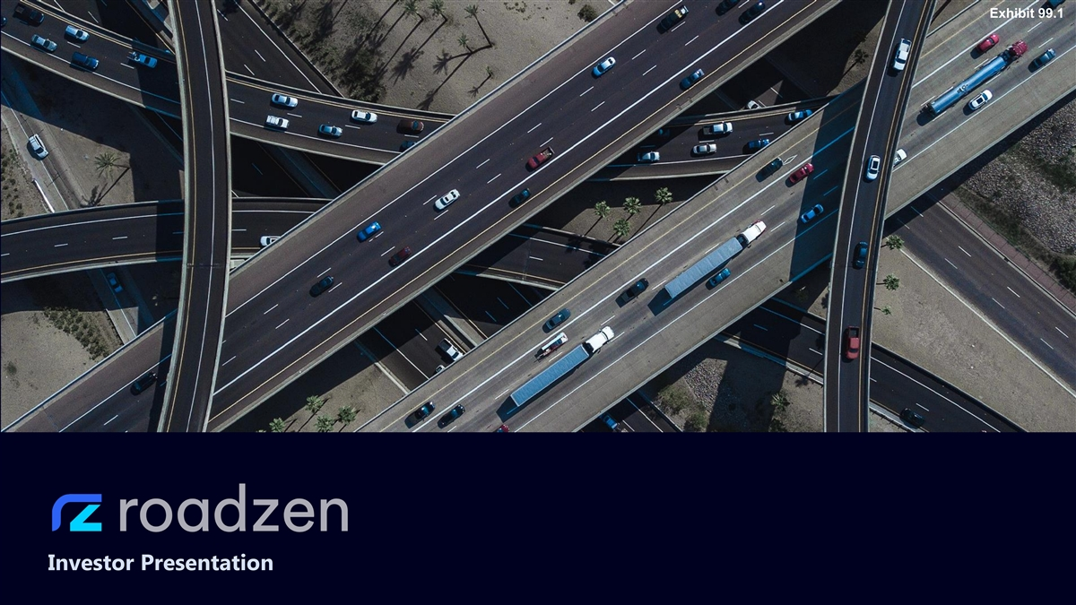
Exhibit 99.1 Investor Presentation

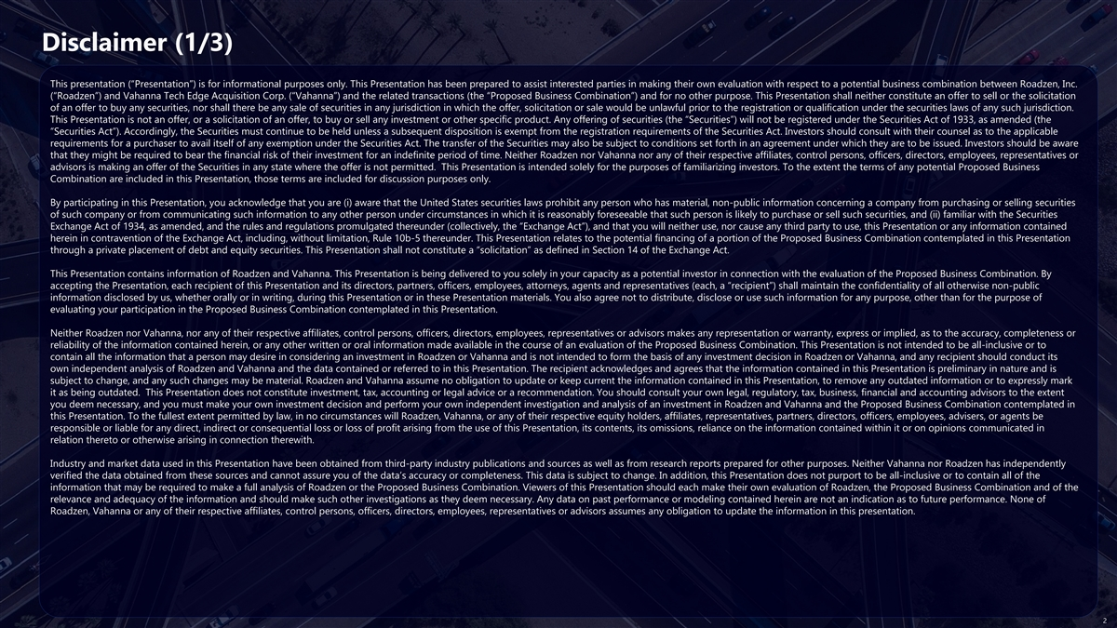
Disclaimer (1/3) This presentation (“Presentation”) is for informational purposes only. This Presentation has been prepared to assist interested parties in making their own evaluation with respect to a potential business combination between Roadzen, Inc. (“Roadzen”) and Vahanna Tech Edge Acquisition Corp. (“Vahanna”) and the related transactions (the “Proposed Business Combination”) and for no other purpose. This Presentation shall neither constitute an offer to sell or the solicitation of an offer to buy any securities, nor shall there be any sale of securities in any jurisdiction in which the offer, solicitation or sale would be unlawful prior to the registration or qualification under the securities laws of any such jurisdiction. This Presentation is not an offer, or a solicitation of an offer, to buy or sell any investment or other specific product. Any offering of securities (the “Securities”) will not be registered under the Securities Act of 1933, as amended (the “Securities Act”). Accordingly, the Securities must continue to be held unless a subsequent disposition is exempt from the registration requirements of the Securities Act. Investors should consult with their counsel as to the applicable requirements for a purchaser to avail itself of any exemption under the Securities Act. The transfer of the Securities may also be subject to conditions set forth in an agreement under which they are to be issued. Investors should be aware that they might be required to bear the financial risk of their investment for an indefinite period of time. Neither Roadzen nor Vahanna nor any of their respective afﬁliates, control persons, officers, directors, employees, representatives or advisors is making an offer of the Securities in any state where the offer is not permitted. This Presentation is intended solely for the purposes of familiarizing investors. To the extent the terms of any potential Proposed Business Combination are included in this Presentation, those terms are included for discussion purposes only. By participating in this Presentation, you acknowledge that you are (i) aware that the United States securities laws prohibit any person who has material, non-public information concerning a company from purchasing or selling securities of such company or from communicating such information to any other person under circumstances in which it is reasonably foreseeable that such person is likely to purchase or sell such securities, and (ii) familiar with the Securities Exchange Act of 1934, as amended, and the rules and regulations promulgated thereunder (collectively, the “Exchange Act”), and that you will neither use, nor cause any third party to use, this Presentation or any information contained herein in contravention of the Exchange Act, including, without limitation, Rule 10b-5 thereunder. This Presentation relates to the potential financing of a portion of the Proposed Business Combination contemplated in this Presentation through a private placement of debt and equity securities. This Presentation shall not constitute a “solicitation” as defined in Section 14 of the Exchange Act. This Presentation contains information of Roadzen and Vahanna. This Presentation is being delivered to you solely in your capacity as a potential investor in connection with the evaluation of the Proposed Business Combination. By accepting the Presentation, each recipient of this Presentation and its directors, partners, officers, employees, attorneys, agents and representatives (each, a “recipient”) shall maintain the confidentiality of all otherwise non-public information disclosed by us, whether orally or in writing, during this Presentation or in these Presentation materials. You also agree not to distribute, disclose or use such information for any purpose, other than for the purpose of evaluating your participation in the Proposed Business Combination contemplated in this Presentation. Neither Roadzen nor Vahanna, nor any of their respective afﬁliates, control persons, officers, directors, employees, representatives or advisors makes any representation or warranty, express or implied, as to the accuracy, completeness or reliability of the information contained herein, or any other written or oral information made available in the course of an evaluation of the Proposed Business Combination. This Presentation is not intended to be all-inclusive or to contain all the information that a person may desire in considering an investment in Roadzen or Vahanna and is not intended to form the basis of any investment decision in Roadzen or Vahanna, and any recipient should conduct its own independent analysis of Roadzen and Vahanna and the data contained or referred to in this Presentation. The recipient acknowledges and agrees that the information contained in this Presentation is preliminary in nature and is subject to change, and any such changes may be material. Roadzen and Vahanna assume no obligation to update or keep current the information contained in this Presentation, to remove any outdated information or to expressly mark it as being outdated. This Presentation does not constitute investment, tax, accounting or legal advice or a recommendation. You should consult your own legal, regulatory, tax, business, financial and accounting advisors to the extent you deem necessary, and you must make your own investment decision and perform your own independent investigation and analysis of an investment in Roadzen and Vahanna and the Proposed Business Combination contemplated in this Presentation. To the fullest extent permitted by law, in no circumstances will Roadzen, Vahanna, or any of their respective equity holders, afﬁliates, representatives, partners, directors, ofﬁcers, employees, advisers, or agents be responsible or liable for any direct, indirect or consequential loss or loss of proﬁt arising from the use of this Presentation, its contents, its omissions, reliance on the information contained within it or on opinions communicated in relation thereto or otherwise arising in connection therewith. Industry and market data used in this Presentation have been obtained from third-party industry publications and sources as well as from research reports prepared for other purposes. Neither Vahanna nor Roadzen has independently verified the data obtained from these sources and cannot assure you of the data’s accuracy or completeness. This data is subject to change. In addition, this Presentation does not purport to be all-inclusive or to contain all of the information that may be required to make a full analysis of Roadzen or the Proposed Business Combination. Viewers of this Presentation should each make their own evaluation of Roadzen, the Proposed Business Combination and of the relevance and adequacy of the information and should make such other investigations as they deem necessary. Any data on past performance or modeling contained herein are not an indication as to future performance. None of Roadzen, Vahanna or any of their respective afﬁliates, control persons, officers, directors, employees, representatives or advisors assumes any obligation to update the information in this presentation. 2

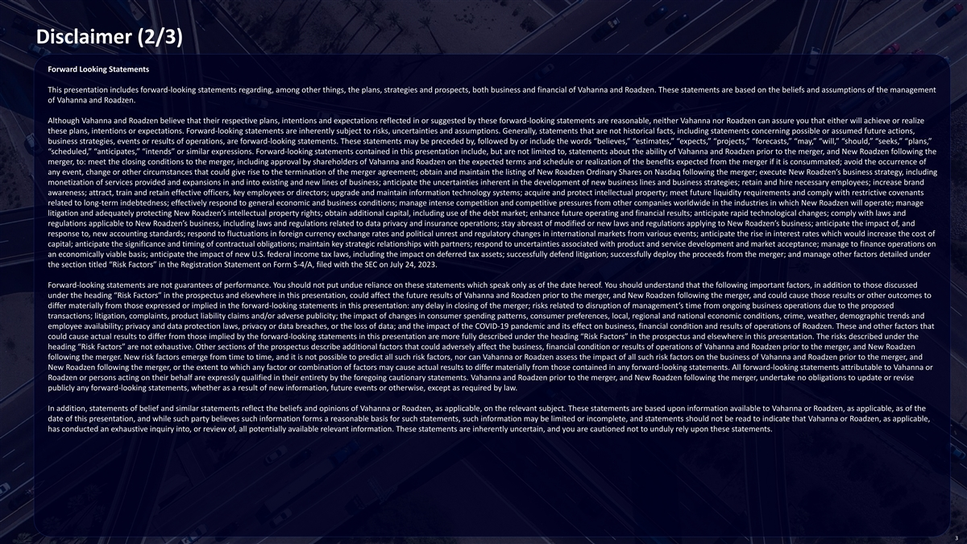
Disclaimer (2/3) Forward Looking Statements This presentation includes forward-looking statements regarding, among other things, the plans, strategies and prospects, both business and financial of Vahanna and Roadzen. These statements are based on the beliefs and assumptions of the management of Vahanna and Roadzen. Although Vahanna and Roadzen believe that their respective plans, intentions and expectations reflected in or suggested by these forward-looking statements are reasonable, neither Vahanna nor Roadzen can assure you that either will achieve or realize these plans, intentions or expectations. Forward-looking statements are inherently subject to risks, uncertainties and assumptions. Generally, statements that are not historical facts, including statements concerning possible or assumed future actions, business strategies, events or results of operations, are forward-looking statements. These statements may be preceded by, followed by or include the words “believes,” “estimates,” “expects,” “projects,” “forecasts,” “may,” “will,” “should,” “seeks,” “plans,” “scheduled,” “anticipates,” “intends” or similar expressions. Forward-looking statements contained in this presentation include, but are not limited to, statements about the ability of Vahanna and Roadzen prior to the merger, and New Roadzen following the merger, to: meet the closing conditions to the merger, including approval by shareholders of Vahanna and Roadzen on the expected terms and schedule or realization of the benefits expected from the merger if it is consummated; avoid the occurrence of any event, change or other circumstances that could give rise to the termination of the merger agreement; obtain and maintain the listing of New Roadzen Ordinary Shares on Nasdaq following the merger; execute New Roadzen’s business strategy, including monetization of services provided and expansions in and into existing and new lines of business; anticipate the uncertainties inherent in the development of new business lines and business strategies; retain and hire necessary employees; increase brand awareness; attract, train and retain effective officers, key employees or directors; upgrade and maintain information technology systems; acquire and protect intellectual property; meet future liquidity requirements and comply with restrictive covenants related to long-term indebtedness; effectively respond to general economic and business conditions; manage intense competition and competitive pressures from other companies worldwide in the industries in which New Roadzen will operate; manage litigation and adequately protecting New Roadzen’s intellectual property rights; obtain additional capital, including use of the debt market; enhance future operating and financial results; anticipate rapid technological changes; comply with laws and regulations applicable to New Roadzen’s business, including laws and regulations related to data privacy and insurance operations; stay abreast of modified or new laws and regulations applying to New Roadzen’s business; anticipate the impact of, and response to, new accounting standards; respond to fluctuations in foreign currency exchange rates and political unrest and regulatory changes in international markets from various events; anticipate the rise in interest rates which would increase the cost of capital; anticipate the significance and timing of contractual obligations; maintain key strategic relationships with partners; respond to uncertainties associated with product and service development and market acceptance; manage to finance operations on an economically viable basis; anticipate the impact of new U.S. federal income tax laws, including the impact on deferred tax assets; successfully defend litigation; successfully deploy the proceeds from the merger; and manage other factors detailed under the section titled “Risk Factors” in the Registration Statement on Form S-4/A, filed with the SEC on July 24, 2023. Forward-looking statements are not guarantees of performance. You should not put undue reliance on these statements which speak only as of the date hereof. You should understand that the following important factors, in addition to those discussed under the heading “Risk Factors” in the prospectus and elsewhere in this presentation, could affect the future results of Vahanna and Roadzen prior to the merger, and New Roadzen following the merger, and could cause those results or other outcomes to differ materially from those expressed or implied in the forward-looking statements in this presentation: any delay in closing of the merger; risks related to disruption of management’s time from ongoing business operations due to the proposed transactions; litigation, complaints, product liability claims and/or adverse publicity; the impact of changes in consumer spending patterns, consumer preferences, local, regional and national economic conditions, crime, weather, demographic trends and employee availability; privacy and data protection laws, privacy or data breaches, or the loss of data; and the impact of the COVID-19 pandemic and its effect on business, financial condition and results of operations of Roadzen. These and other factors that could cause actual results to differ from those implied by the forward-looking statements in this presentation are more fully described under the heading “Risk Factors” in the prospectus and elsewhere in this presentation. The risks described under the heading “Risk Factors” are not exhaustive. Other sections of the prospectus describe additional factors that could adversely affect the business, financial condition or results of operations of Vahanna and Roadzen prior to the merger, and New Roadzen following the merger. New risk factors emerge from time to time, and it is not possible to predict all such risk factors, nor can Vahanna or Roadzen assess the impact of all such risk factors on the business of Vahanna and Roadzen prior to the merger, and New Roadzen following the merger, or the extent to which any factor or combination of factors may cause actual results to differ materially from those contained in any forward-looking statements. All forward-looking statements attributable to Vahanna or Roadzen or persons acting on their behalf are expressly qualified in their entirety by the foregoing cautionary statements. Vahanna and Roadzen prior to the merger, and New Roadzen following the merger, undertake no obligations to update or revise publicly any forward-looking statements, whether as a result of new information, future events or otherwise, except as required by law. In addition, statements of belief and similar statements reflect the beliefs and opinions of Vahanna or Roadzen, as applicable, on the relevant subject. These statements are based upon information available to Vahanna or Roadzen, as applicable, as of the date of this presentation, and while such party believes such information forms a reasonable basis for such statements, such information may be limited or incomplete, and statements should not be read to indicate that Vahanna or Roadzen, as applicable, has conducted an exhaustive inquiry into, or review of, all potentially available relevant information. These statements are inherently uncertain, and you are cautioned not to unduly rely upon these statements. 3

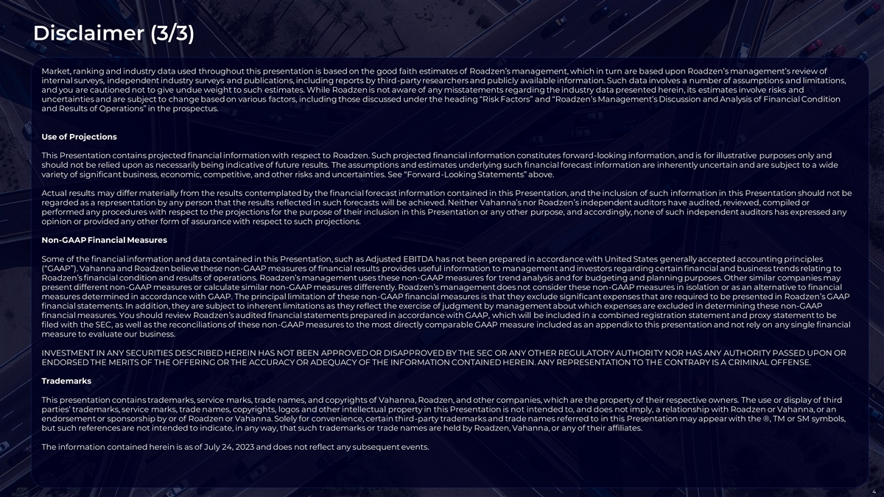
Disclaimer (3/3) Market, ranking and industry data used throughout this presentation is based on the good faith estimates of Roadzen’s management, which in turn are based upon Roadzen’s management’s review of internal surveys, independent industry surveys and publications, including reports by third-party researchers and publicly available information. Such data involves a number of assumptions and limitations, and you are cautioned not to give undue weight to such estimates. While Roadzen is not aware of any misstatements regarding the industry data presented herein, its estimates involve risks and uncertainties and are subject to change based on various factors, including those discussed under the heading “Risk Factors” and “Roadzen’s Management’s Discussion and Analysis of Financial Condition and Results of Operations” in the prospectus. Use of Projections This Presentation contains projected financial information with respect to Roadzen. Such projected financial information constitutes forward-looking information, and is for illustrative purposes only and should not be relied upon as necessarily being indicative of future results. The assumptions and estimates underlying such financial forecast information are inherently uncertain and are subject to a wide variety of significant business, economic, competitive, and other risks and uncertainties. See “Forward-Looking Statements” above. Actual results may differ materially from the results contemplated by the financial forecast information contained in this Presentation, and the inclusion of such information in this Presentation should not be regarded as a representation by any person that the results reflected in such forecasts will be achieved. Neither Vahanna’s nor Roadzen’s independent auditors have audited, reviewed, compiled or performed any procedures with respect to the projections for the purpose of their inclusion in this Presentation or any other purpose, and accordingly, none of such independent auditors has expressed any opinion or provided any other form of assurance with respect to such projections. Non-GAAP Financial Measures Some of the financial information and data contained in this Presentation, such as Adjusted EBITDA has not been prepared in accordance with United States generally accepted accounting principles (“GAAP”). Vahanna and Roadzen believe these non-GAAP measures of financial results provides useful information to management and investors regarding certain financial and business trends relating to Roadzen’s financial condition and results of operations. Roadzen’s management uses these non-GAAP measures for trend analysis and for budgeting and planning purposes. Other similar companies may present different non-GAAP measures or calculate similar non-GAAP measures differently. Roadzen’s management does not consider these non-GAAP measures in isolation or as an alternative to financial measures determined in accordance with GAAP. The principal limitation of these non-GAAP financial measures is that they exclude significant expenses that are required to be presented in Roadzen’s GAAP financial statements. In addition, they are subject to inherent limitations as they reflect the exercise of judgment by management about which expenses are excluded in determining these non-GAAP financial measures. You should review Roadzen’s audited financial statements prepared in accordance with GAAP, which will be included in a combined registration statement and proxy statement to be filed with the SEC, as well as the reconciliations of these non-GAAP measures to the most directly comparable GAAP measure included as an appendix to this presentation and not rely on any single financial measure to evaluate our business. INVESTMENT IN ANY SECURITIES DESCRIBED HEREIN HAS NOT BEEN APPROVED OR DISAPPROVED BY THE SEC OR ANY OTHER REGULATORY AUTHORITY NOR HAS ANY AUTHORITY PASSED UPON OR ENDORSED THE MERITS OF THE OFFERING OR THE ACCURACY OR ADEQUACY OF THE INFORMATION CONTAINED HEREIN. ANY REPRESENTATION TO THE CONTRARY IS A CRIMINAL OFFENSE. Trademarks This presentation contains trademarks, service marks, trade names, and copyrights of Vahanna, Roadzen, and other companies, which are the property of their respective owners. The use or display of third parties’ trademarks, service marks, trade names, copyrights, logos and other intellectual property in this Presentation is not intended to, and does not imply, a relationship with Roadzen or Vahanna, or an endorsement or sponsorship by or of Roadzen or Vahanna. Solely for convenience, certain third-party trademarks and trade names referred to in this Presentation may appear with the ®, TM or SM symbols, but such references are not intended to indicate, in any way, that such trademarks or trade names are held by Roadzen, Vahanna, or any of their affiliates. The information contained herein is as of July 24, 2023 and does not reflect any subsequent events. 4

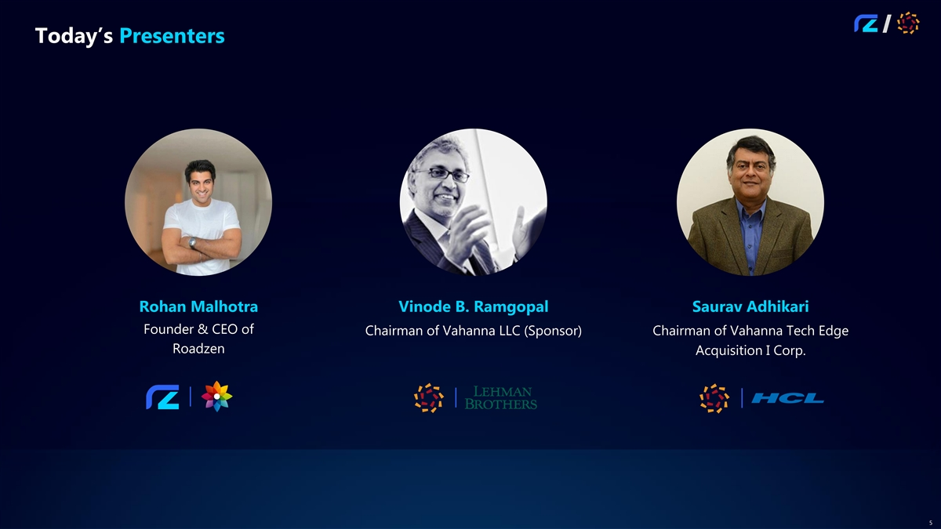
Today’s Presenters Rohan Malhotra Vinode B. Ramgopal Saurav Adhikari Founder & CEO of Chairman of Vahanna LLC (Sponsor) Chairman of Vahanna Tech Edge Roadzen Acquisition I Corp. 5


Key Investment Highlights A Leading Global Insurtech Platform First insurtech going global with platforms Roadzen is transforming global & partnerships in India, US, EU/UK, ME, SEA and distribution licenses targeting a US$ auto insurance using applied AI 1 817bn global auto insurance market Scalable, High Margin AI at the Core Made in India for the World Accelerating organic growth through Award-winning independent AI Tech built in India’s low cost, high two revenue models – Insurance as a research lab producing industry- growth market now addressing Service (IaaS) and Brokerage – with no leading models in computer vision, large, high margin markets in US underwriting risk and limited capital language models and generative AI and Europe requirements for growth addressing insurance and mobility Strong M&A Track Record Technology-led B2B2C model High Growth Growing from ~$58.6m FY 2023 Attacking the core cost drivers for Targeted M&A across a fragmented insurance – operations, distribution, revenue, to $118m FY 2024E revenue insurance distribution landscape ripe for 2 claims – using technology to deliver (9x growth last 3 years) with margin consolidation, using technology as a acceleration across extensive pipeline strong fundamentals, recurring catalyst to increase sales and lower of over $250m revenue with global revenue and attractive margins operating costs blue-chip clients 1. https://www.factmr.com/report/automobile-insurance-market 2. FY21 revenue $13.5m and FY24E revenue $118.3m 6

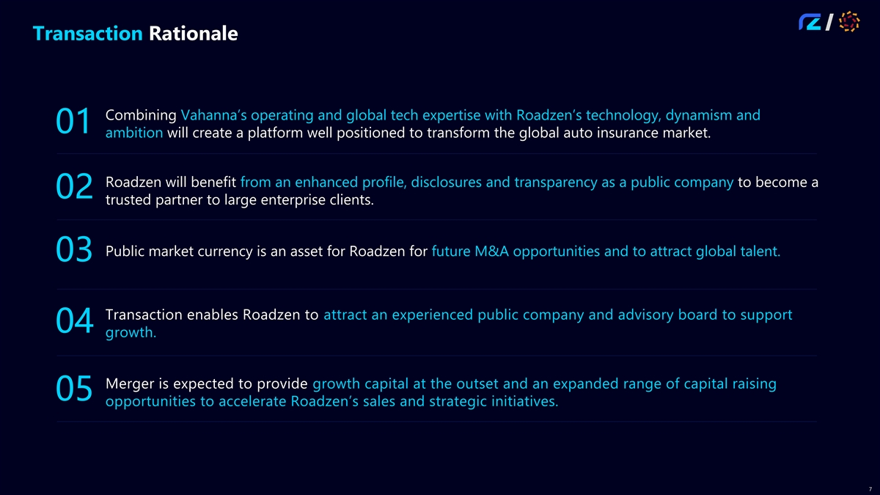
Transaction Rationale Combining Vahanna’s operating and global tech expertise with Roadzen’s technology, dynamism and 01 ambition will create a platform well positioned to transform the global auto insurance market. Roadzen will benefit from an enhanced profile, disclosures and transparency as a public company to become a 02 trusted partner to large enterprise clients. Public market currency is an asset for Roadzen for future M&A opportunities and to attract global talent. 03 Transaction enables Roadzen to attract an experienced public company and advisory board to support 04 growth. Merger is expected to provide growth capital at the outset and an expanded range of capital raising 05 opportunities to accelerate Roadzen’s sales and strategic initiatives. 7

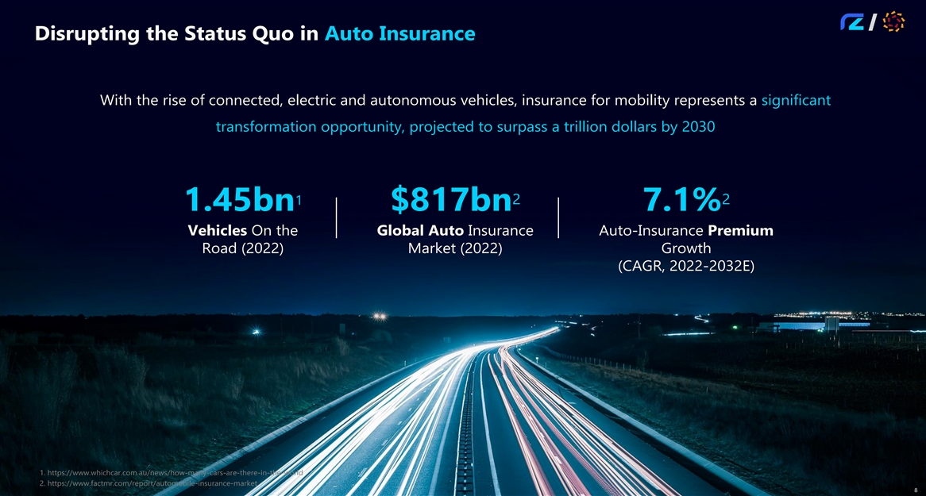
Disrupting the Status Quo in Auto Insurance With the rise of connected, electric and autonomous vehicles, insurance for mobility represents a significant transformation opportunity, projected to surpass a trillion dollars by 2030 2 2 1 1.45bn $817bn 7.1% Vehicles On the Global Auto Insurance Auto-Insurance Premium Road (2022) Market (2022) Growth (CAGR, 2022-2032E) 1. https://www.whichcar.com.au/news/how-many-cars-are-there-in-the-world 2. https://www.factmr.com/report/automobile-insurance-market 8

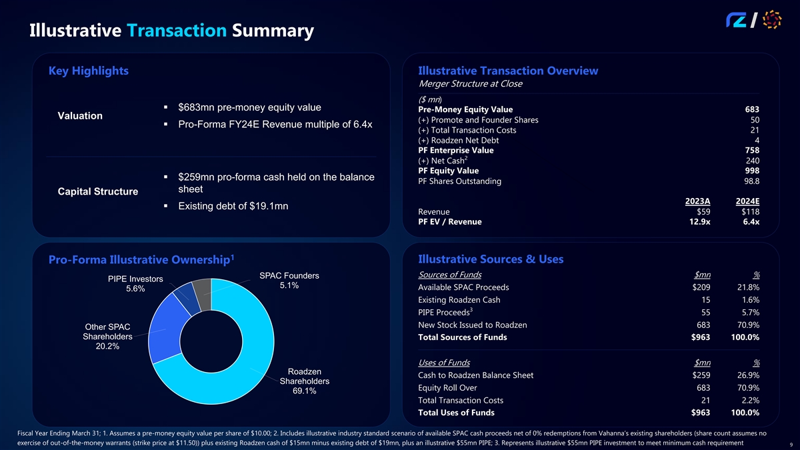
Illustrative Transaction Summary Key Highlights Illustrative Transaction Overview Merger Structure at Close ($ mn) § $683mn pre-money equity value Pre-Money Equity Value 683 Valuation (+) Promote and Founder Shares 50 § Pro-Forma FY24E Revenue multiple of 6.4x (+) Total Transaction Costs 21 (+) Roadzen Net Debt 4 PF Enterprise Value 758 2 (+) Net Cash 240 PF Equity Value 998 § $259mn pro-forma cash held on the balance PF Shares Outstanding 98.8 sheet Capital Structure 2023A 2024E § Existing debt of $19.1mn Revenue $59 $118 PF EV / Revenue 12.9x 6.4x 1 Illustrative Sources & Uses Pro-Forma Illustrative Ownership Sources of Funds $mn % SPAC Founders PIPE Investors 5.1% Available SPAC Proceeds $209 21.8% 5.6% Existing Roadzen Cash 15 1.6% 3 PIPE Proceeds 55 5.7% New Stock Issued to Roadzen 683 70.9% Other SPAC Shareholders Total Sources of Funds $963 100.0% 20.2% Uses of Funds $mn % Roadzen Cash to Roadzen Balance Sheet $259 26.9% Shareholders Equity Roll Over 683 70.9% 69.1% Total Transaction Costs 21 2.2% Total Uses of Funds $963 100.0% Fiscal Year Ending March 31; 1. Assumes a pre-money equity value per share of $10.00; 2. Includes illustrative industry standard scenario of available SPAC cash proceeds net of 0% redemptions from Vahanna’s existing shareholders (share count assumes no exercise of out-of-the-money warrants (strike price at $11.50)) plus existing Roadzen cash of $15mn minus existing debt of $19mn, plus an illustrative $55mn PIPE; 3. Represents illustrative $55mn PIPE investment to meet minimum cash requirement 9

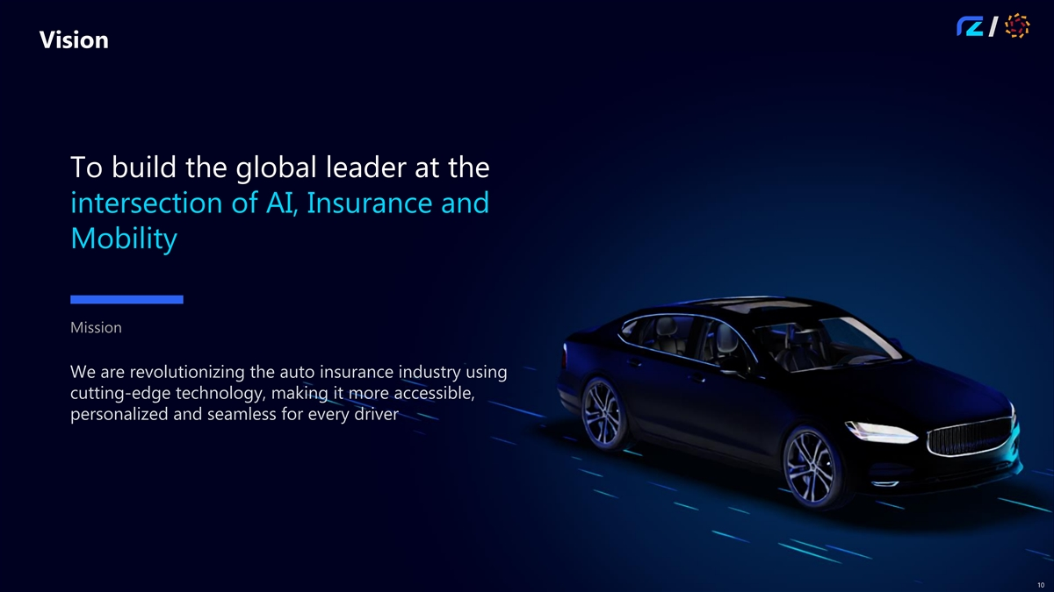
Vision To build the global leader at the intersection of AI, Insurance and Mobility Mission We are revolutionizing the auto insurance industry using cutting-edge technology, making it more accessible, personalized and seamless for every driver 10

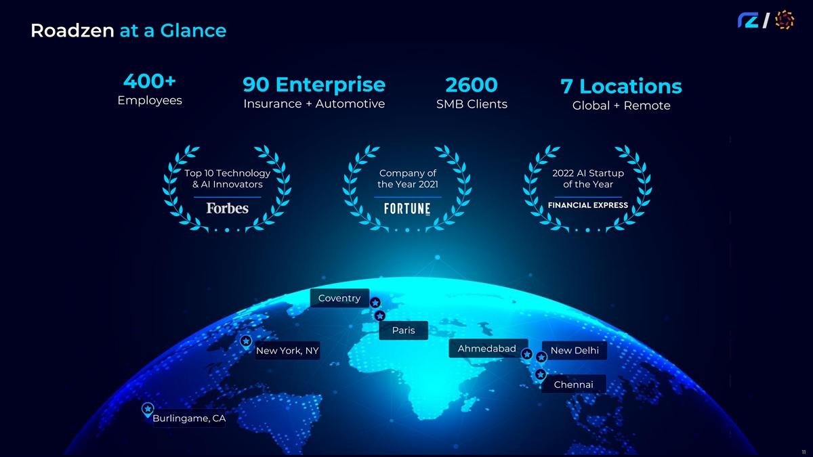
Roadzen at a Glance 400+ 90 Enterprise 2600 7 Locations Employees Insurance + Automotive SMB Clients Global + Remote Top 10 Technology Company of 2022 AI Startup & AI Innovators the Year 2021 of the Year Coventry Paris Ahmedabad New Delhi New York, NY Chennai Burlingame, CA 11

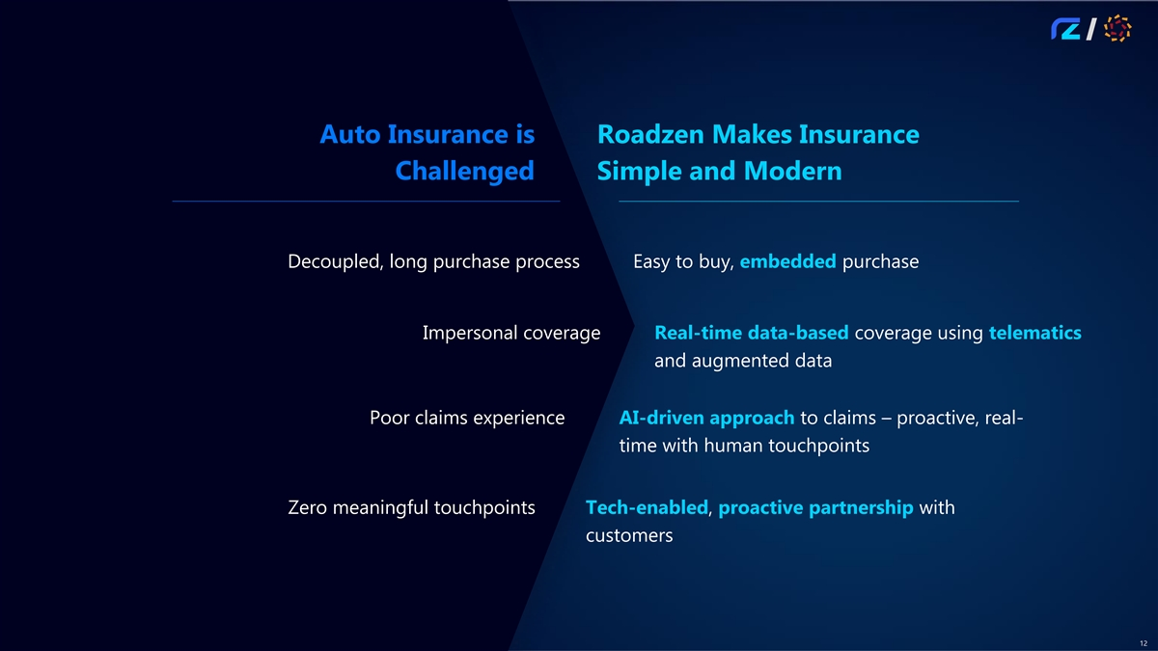
Auto Insurance is Roadzen Makes Insurance Challenged Simple and Modern Decoupled, long purchase process Easy to buy, embedded purchase Impersonal coverage Real-time data-based coverage using telematics and augmented data Poor claims experience AI-driven approach to claims – proactive, real- time with human touchpoints Zero meaningful touchpoints Tech-enabled, proactive partnership with customers 12

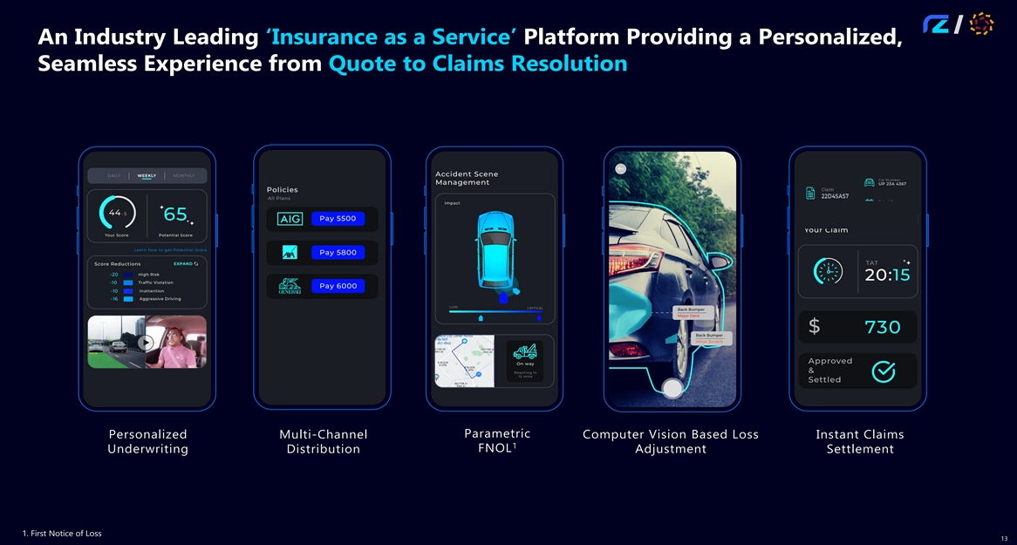
An Industry Leading ‘Insurance as a Service’ Platform Providing a Personalized, Seamless Experience from Quote to Claims Resolution Parametric Computer Vision Based Loss Personalized Multi-Channel Instant Claims 1 FNOL Underwriting Distribution Adjustment Settlement 1. First Notice of Loss 13

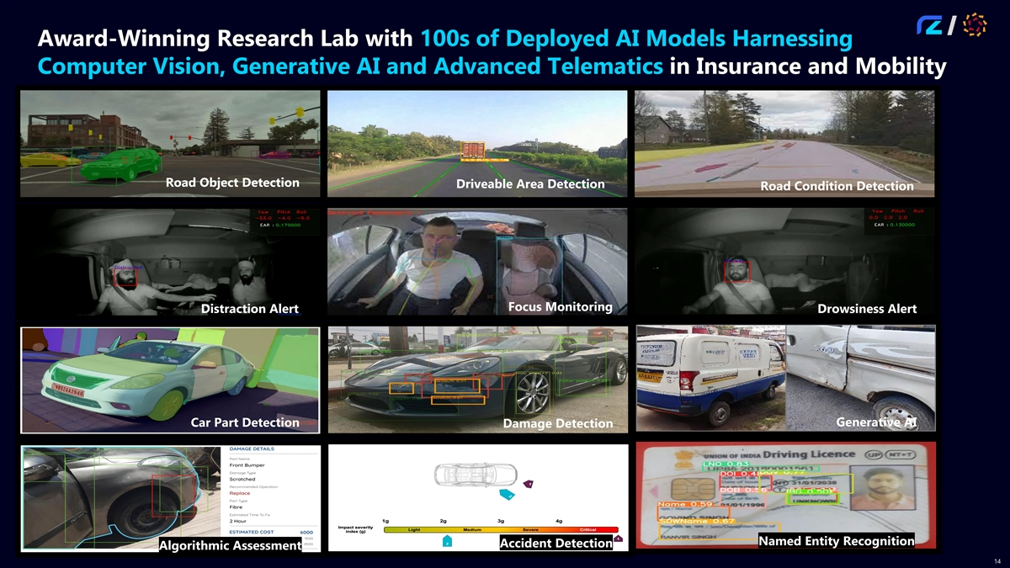
Award-Winning Research Lab with 100s of Deployed AI Models Harnessing Computer Vision, Generative AI and Advanced Telematics in Insurance and Mobility Road Object Detection Driveable Area Detection Road Condition Detection Focus Monitoring Distraction Alert Drowsiness Alert Generative AI Car Part Detection Damage Detection Named Entity Recognition Accident Detection Algorithmic Assessment 14

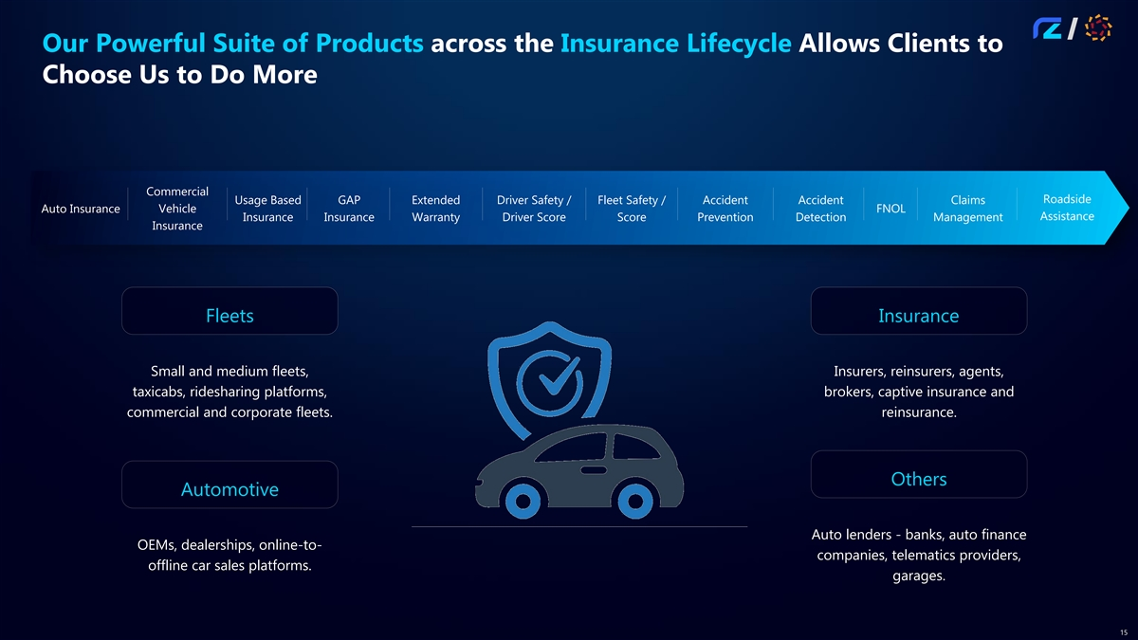
Our Powerful Suite of Products across the Insurance Lifecycle Allows Clients to Choose Us to Do More Commercial Roadside Usage Based GAP Extended Driver Safety / Fleet Safety / Accident Accident Claims Auto Insurance Vehicle FNOL Assistance Insurance Insurance Warranty Driver Score Score Prevention Detection Management Insurance Fleets Insurance Small and medium fleets, Insurers, reinsurers, agents, taxicabs, ridesharing platforms, brokers, captive insurance and commercial and corporate fleets. reinsurance. Others Automotive Auto lenders - banks, auto finance OEMs, dealerships, online-to- companies, telematics providers, offline car sales platforms. garages. 15

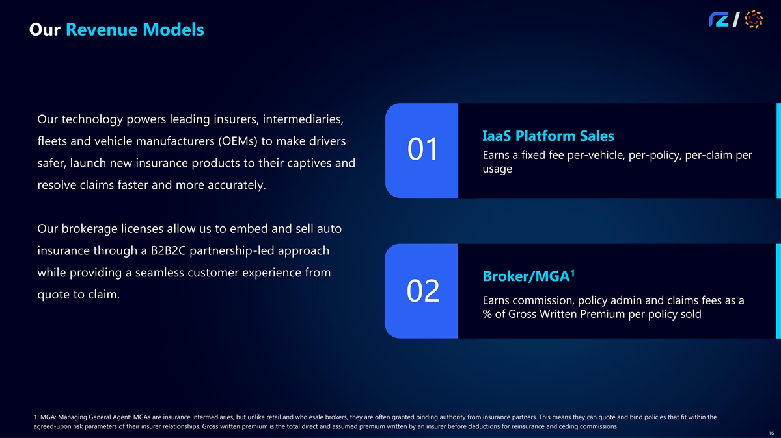
Our Revenue Models Our technology powers leading insurers, intermediaries, IaaS Platform Sales fleets and vehicle manufacturers (OEMs) to make drivers Earns a fixed fee per-vehicle, per-policy, per-claim per 01 safer, launch new insurance products to their captives and usage resolve claims faster and more accurately. Our brokerage licenses allow us to embed and sell auto insurance through a B2B2C partnership-led approach while providing a seamless customer experience from 1 Broker/MGA quote to claim. 02 Earns commission, policy admin and claims fees as a % of Gross Written Premium per policy sold 1. MGA: Managing General Agent: MGAs are insurance intermediaries, but unlike retail and wholesale brokers, they are often granted binding authority from insurance partners. This means they can quote and bind policies that fit within the agreed-upon risk parameters of their insurer relationships. Gross written premium is the total direct and assumed premium written by an insurer before deductions for reinsurance and ceding commissions 16

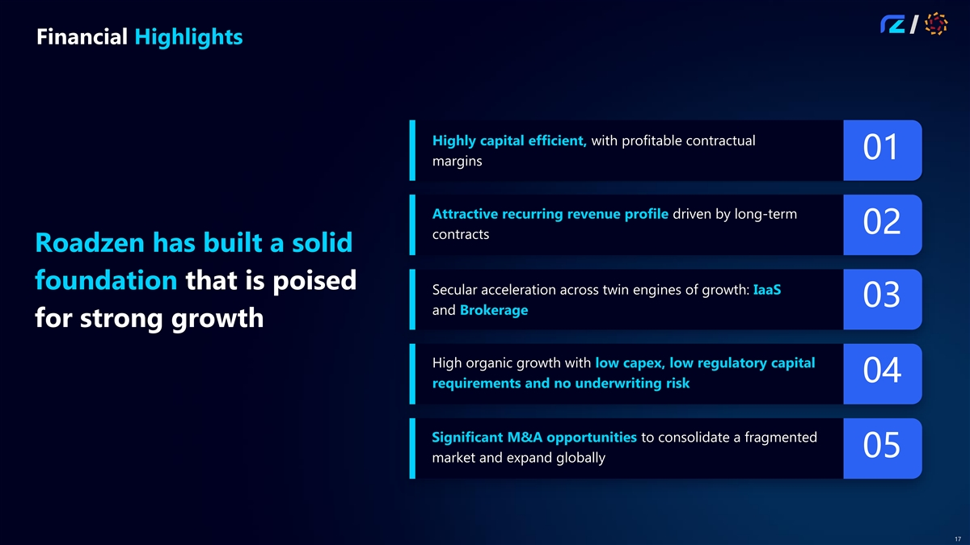
Financial Highlights Highly capital efficient, with profitable contractual 01 margins Attractive recurring revenue profile driven by long-term 02 contracts Roadzen has built a solid foundation that is poised Secular acceleration across twin engines of growth: IaaS 03 and Brokerage for strong growth High organic growth with low capex, low regulatory capital 04 requirements and no underwriting risk Significant M&A opportunities to consolidate a fragmented 05 market and expand globally 17

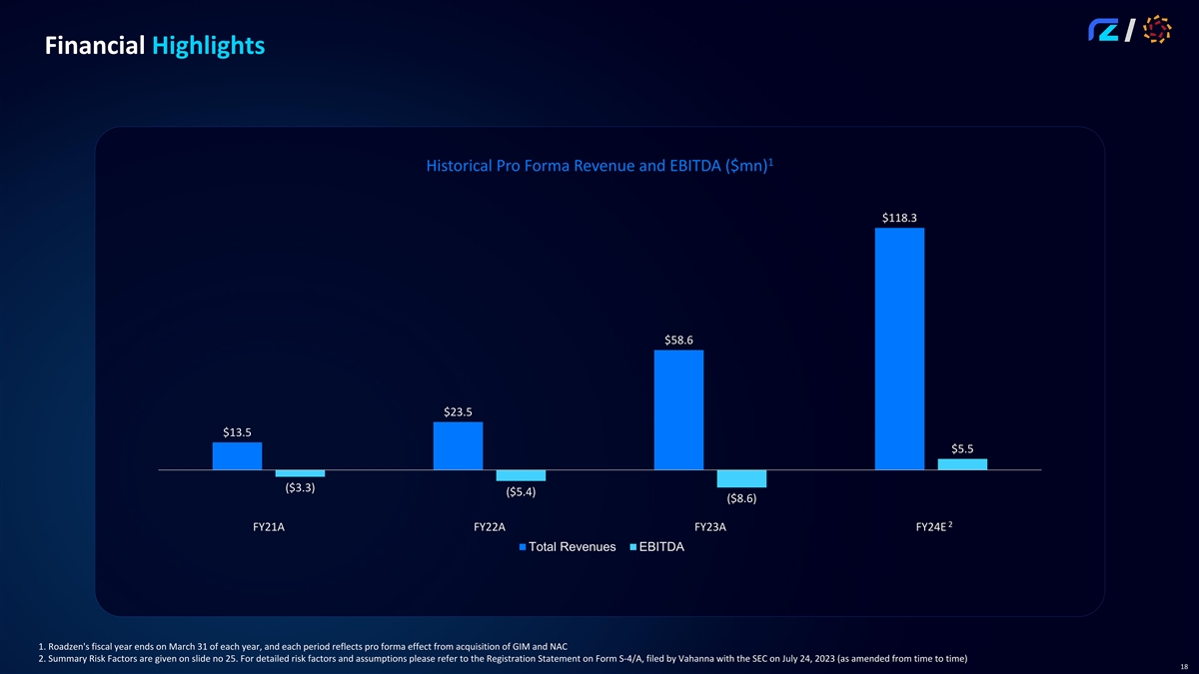
Financial Highlights 1 Historical Pro Forma Revenue and EBITDA ($mn) $118.3 $58.6 $23.5 $13.5 $5.5 ($3.3) ($5.4) ($8.6) 2 FY21A FY22A FY23A FY24E Total Revenues EBITDA 1. Roadzen's fiscal year ends on March 31 of each year, and each period reflects pro forma effect from acquisition of GIM and NAC 2. Summary Risk Factors are given on slide no 25. For detailed risk factors and assumptions please refer to the Registration Statement on Form S-4/A, filed by Vahanna with the SEC on July 24, 2023 (as amended from time to time) 18

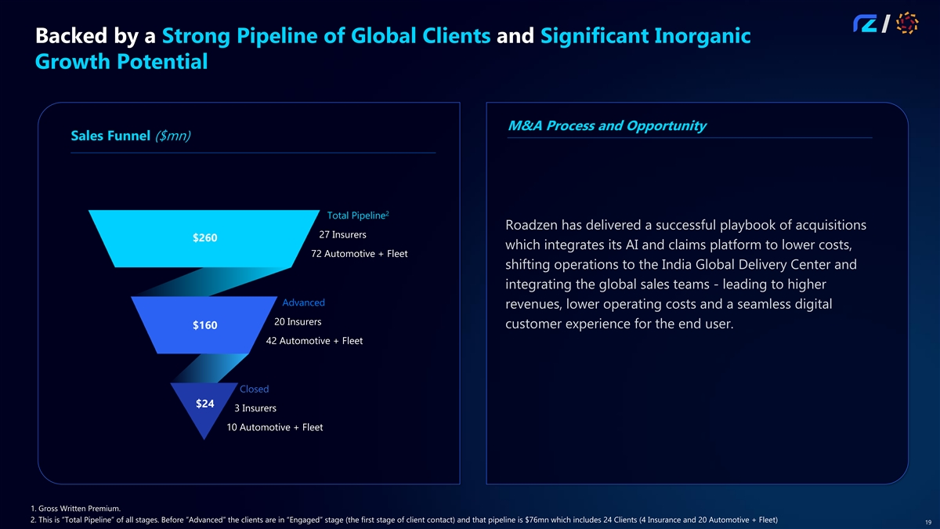
Backed by a Strong Pipeline of Global Clients and Significant Inorganic Growth Potential M&A Process and Opportunity Sales Funnel ($mn) 2 Total Pipeline Roadzen has delivered a successful playbook of acquisitions 27 Insurers $260 which integrates its AI and claims platform to lower costs, 72 Automotive + Fleet shifting operations to the India Global Delivery Center and integrating the global sales teams - leading to higher Advanced revenues, lower operating costs and a seamless digital 20 Insurers customer experience for the end user. $160 42 Automotive + Fleet Closed $24 3 Insurers 10 Automotive + Fleet 1. Gross Written Premium. 2. This is ”Total Pipeline” of all stages. Before ”Advanced” the clients are in “Engaged” stage (the first stage of client contact) and that pipeline is $76mn which includes 24 Clients (4 Insurance and 20 Automotive + Fleet) 19

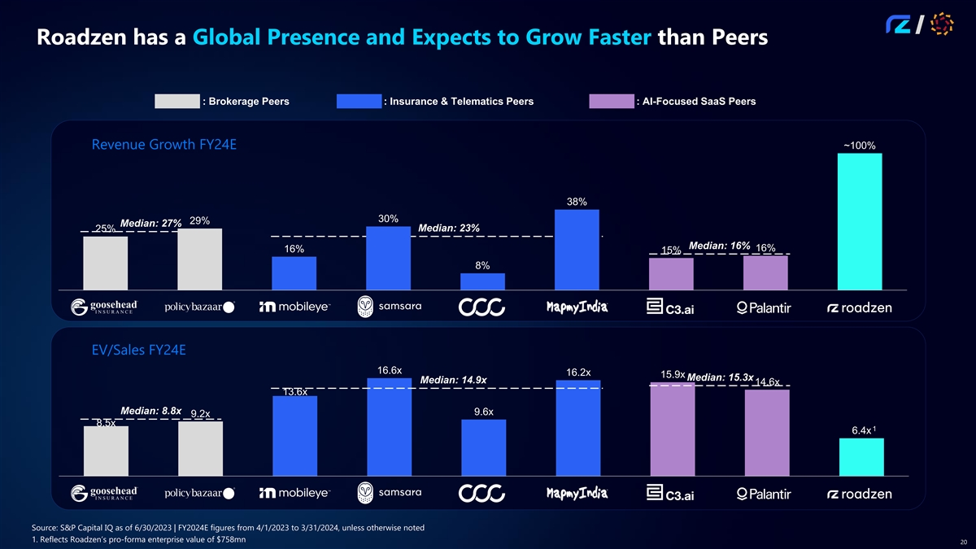
Roadzen has a Global Presence and Expects to Grow Faster than Peers : Brokerage Peers : Insurance & Telematics Peers : AI-Focused SaaS Peers Revenue Growth FY24E ~100% 38% 30% 29% Median: 27% Median: 23% 25% Median: 16% 16% 16% 15% 8% EV/Sales FY24E 16.6x 16.2x 15.9x Median: 15.3x Median: 14.9x 14.6x 13.6x Median: 8.8x 9.6x 9.2x 8.5x 1 6.4x Source: S&P Capital IQ as of 6/30/2023 | FY2024E figures from 4/1/2023 to 3/31/2024, unless otherwise noted 1. Reflects Roadzen’s pro-forma enterprise value of $758mn 20

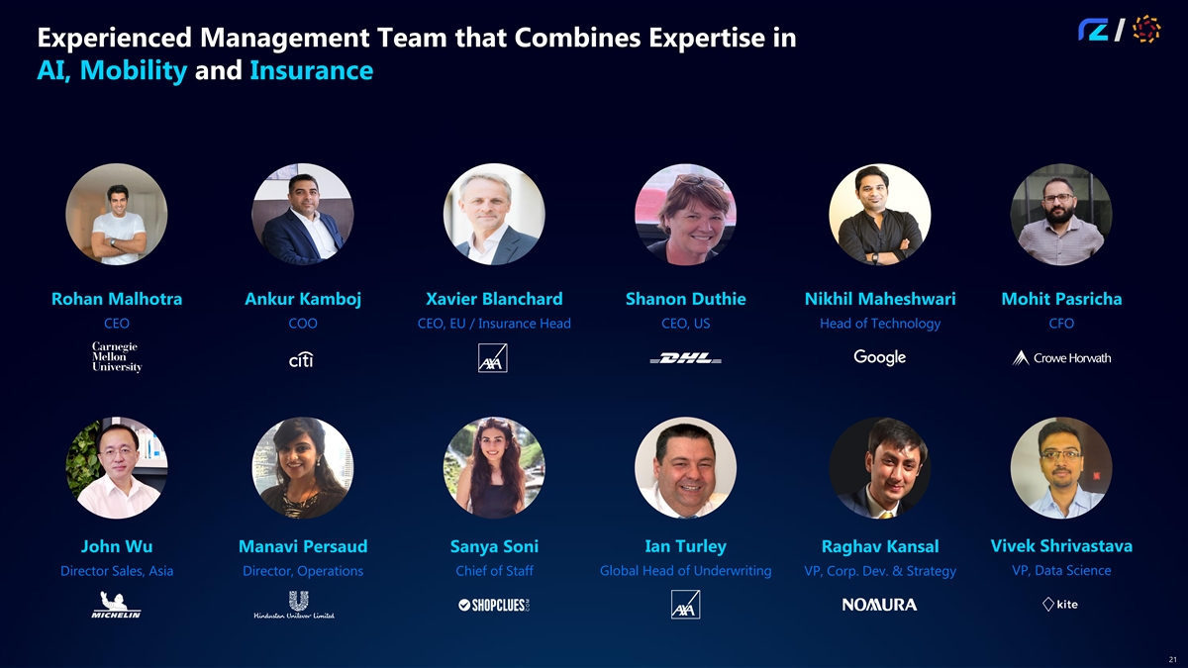
Experienced Management Team that Combines Expertise in AI, Mobility and Insurance Rohan Malhotra Ankur Kamboj Xavier Blanchard Shanon Duthie Nikhil Maheshwari Mohit Pasricha CEO COO CEO, EU / Insurance Head CEO, US Head of Technology CFO Ian Turley Vivek Shrivastava John Wu Manavi Persaud Sanya Soni Raghav Kansal VP, Data Science Director Sales, Asia Director, Operations Chief of Staff Global Head of Underwriting VP, Corp. Dev. & Strategy 21

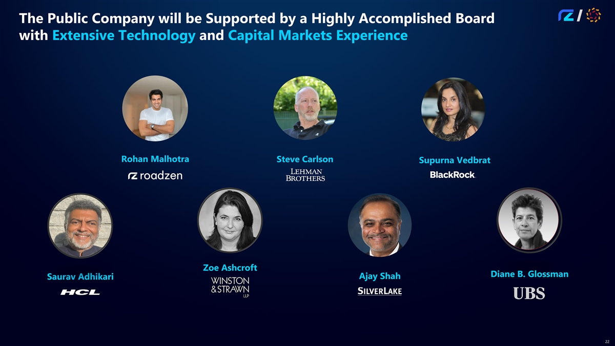
The Public Company will be Supported by a Highly Accomplished Board with Extensive Technology and Capital Markets Experience Rohan Malhotra Steve Carlson Supurna Vedbrat Zoe Ashcroft Diane B. Glossman Ajay Shah Saurav Adhikari 22

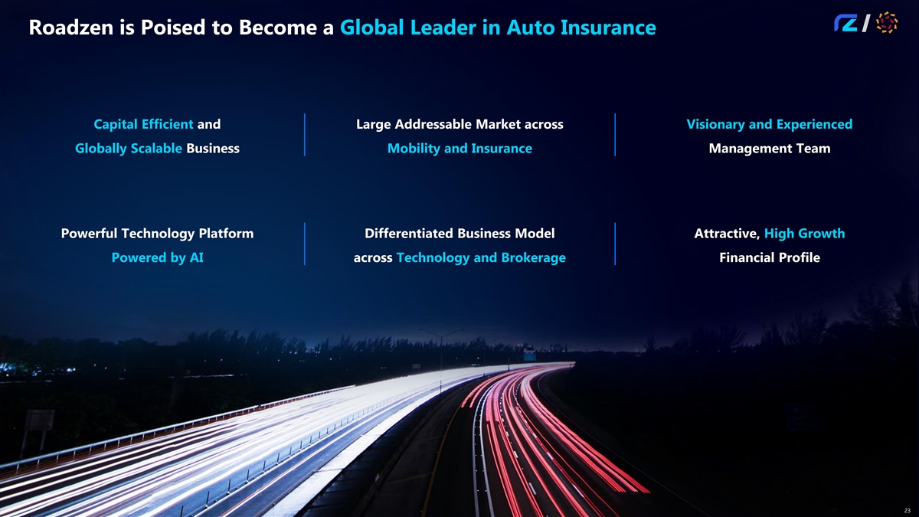
Roadzen is Poised to Become a Global Leader in Auto Insurance Capital Efficient and Large Addressable Market across Visionary and Experienced Globally Scalable Business Mobility and Insurance Management Team Powerful Technology Platform Differentiated Business Model Attractive, High Growth Powered by AI across Technology and Brokerage Financial Profile 23

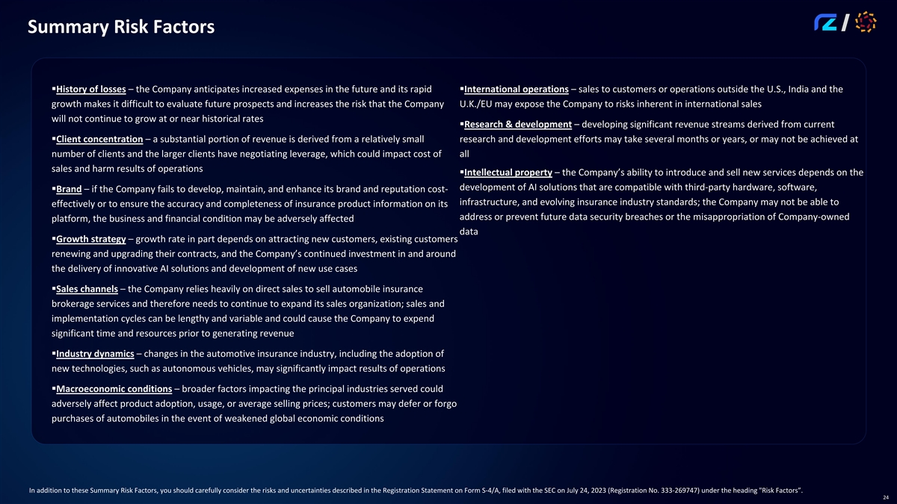
Summary Risk Factors ▪History of losses – the Company anticipates increased expenses in the future and its rapid ▪International operations – sales to customers or operations outside the U.S., India and the growth makes it difficult to evaluate future prospects and increases the risk that the Company U.K./EU may expose the Company to risks inherent in international sales will not continue to grow at or near historical rates ▪Research & development – developing significant revenue streams derived from current ▪Client concentration – a substantial portion of revenue is derived from a relatively small research and development efforts may take several months or years, or may not be achieved at number of clients and the larger clients have negotiating leverage, which could impact cost of all sales and harm results of operations ▪Intellectual property – the Company’s ability to introduce and sell new services depends on the development of AI solutions that are compatible with third-party hardware, software, ▪Brand – if the Company fails to develop, maintain, and enhance its brand and reputation cost- infrastructure, and evolving insurance industry standards; the Company may not be able to effectively or to ensure the accuracy and completeness of insurance product information on its address or prevent future data security breaches or the misappropriation of Company-owned platform, the business and financial condition may be adversely affected data ▪Growth strategy – growth rate in part depends on attracting new customers, existing customers renewing and upgrading their contracts, and the Company’s continued investment in and around the delivery of innovative AI solutions and development of new use cases ▪Sales channels – the Company relies heavily on direct sales to sell automobile insurance brokerage services and therefore needs to continue to expand its sales organization; sales and implementation cycles can be lengthy and variable and could cause the Company to expend significant time and resources prior to generating revenue ▪Industry dynamics – changes in the automotive insurance industry, including the adoption of new technologies, such as autonomous vehicles, may significantly impact results of operations ▪Macroeconomic conditions – broader factors impacting the principal industries served could adversely affect product adoption, usage, or average selling prices; customers may defer or forgo purchases of automobiles in the event of weakened global economic conditions In addition to these Summary Risk Factors, you should carefully consider the risks and uncertainties described in the Registration Statement on Form S-4/A, filed with the SEC on July 24, 2023 (Registration No. 333-269747) under the heading Risk Factors”. 24

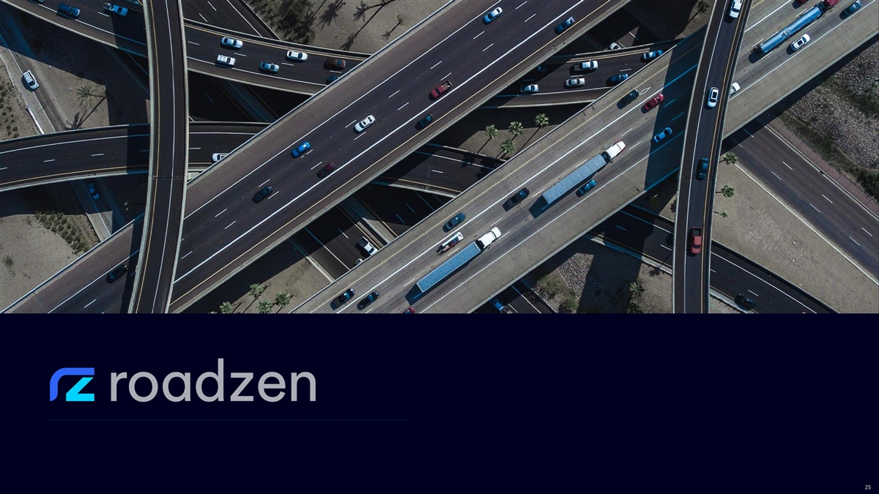
25

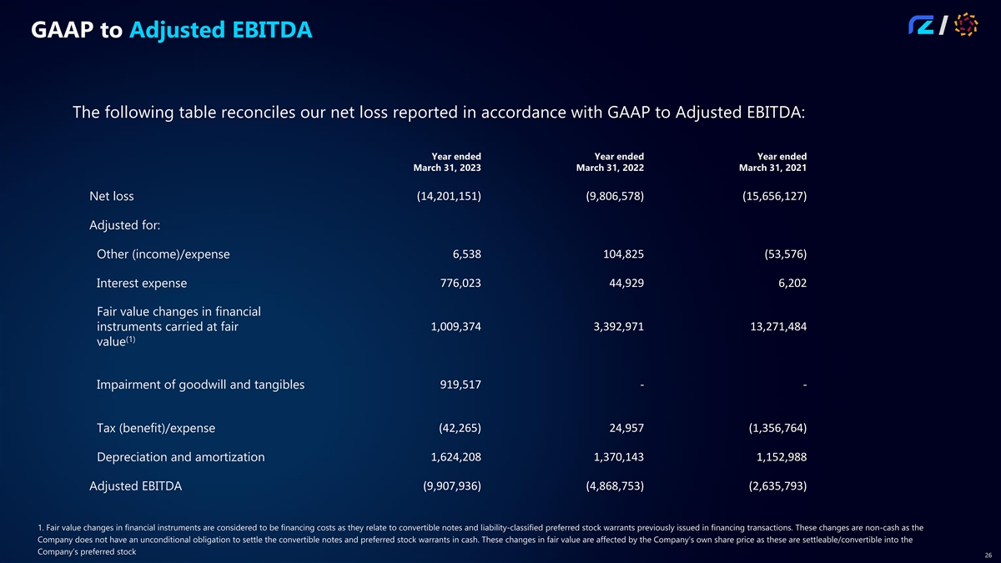
GAAP to Adjusted EBITDA The following table reconciles our net loss reported in accordance with GAAP to Adjusted EBITDA: Year ended Year ended Year ended March 31, 2023 March 31, 2022 March 31, 2021 (14,201,151) (9,806,578) (15,656,127) Net loss Adjusted for: Other (income)/expense 6,538 104,825 (53,576) 776,023 44,929 6,202 Interest expense Fair value changes in financial instruments carried at fair 1,009,374 3,392,971 13,271,484 (1) value Impairment of goodwill and tangibles 919,517 - - (42,265) 24,957 (1,356,764) Tax (benefit)/expense Depreciation and amortization 1,624,208 1,370,143 1,152,988 (9,907,936) (4,868,753) (2,635,793) Adjusted EBITDA 1. Fair value changes in financial instruments are considered to be financing costs as they relate to convertible notes and liability-classified preferred stock warrants previously issued in financing transactions. These changes are non-cash as the Company does not have an unconditional obligation to settle the convertible notes and preferred stock warrants in cash. These changes in fair value are affected by the Company’s own share price as these are settleable/convertible into the Company’s preferred stock 26

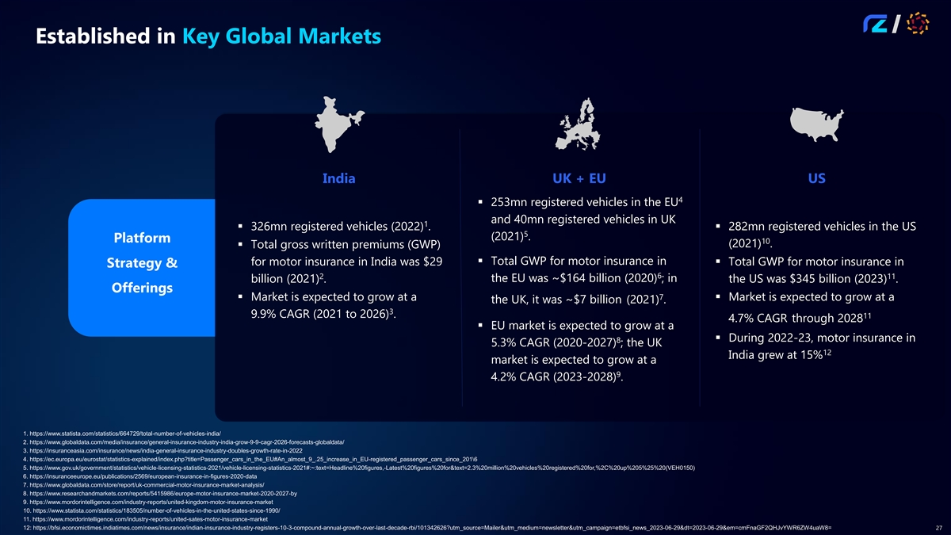
Established in Key Global Markets India UK + EU US 4 § 253mn registered vehicles in the EU and 40mn registered vehicles in UK 1 § 326mn registered vehicles (2022) .§ 282mn registered vehicles in the US 5 (2021) . Platform 10 (2021) . § Total gross written premiums (GWP) § Total GWP for motor insurance in for motor insurance in India was $29 § Total GWP for motor insurance in Strategy & 6 2 11 the EU was ~$164 billion (2020) ; in billion (2021) . the US was $345 billion (2023) . Offerings 7 § Market is expected to grow at a § Market is expected to grow at a the UK, it was ~$7 billion (2021) . 3 9.9% CAGR (2021 to 2026) . 11 4.7% CAGR through 2028 § EU market is expected to grow at a § During 2022-23, motor insurance in 8 5.3% CAGR (2020-2027) ; the UK 12 India grew at 15% market is expected to grow at a 9 4.2% CAGR (2023-2028) . 1. https://www.statista.com/statistics/664729/total-number-of-vehicles-india/ 2. https://www.globaldata.com/media/insurance/general-insurance-industry-india-grow-9-9-cagr-2026-forecasts-globaldata/ 3. https://insuranceasia.com/insurance/news/india-general-insurance-industry-doubles-growth-rate-in-2022 4. https://ec.europa.eu/eurostat/statistics-explained/index.php?title=Passenger_cars_in_the_EU#An_almost_9_.25_increase_in_EU-registered_passenger_cars_since_201\6 5. https://www.gov.uk/government/statistics/vehicle-licensing-statistics-2021/vehicle-licensing-statistics-2021#:~:text=Headline%20figures,-Latest%20figures%20for&text=2.3%20million%20vehicles%20registered%20for,%2C%20up%205%25%20(VEH0150) 6. https://insuranceeurope.eu/publications/2569/european-insurance-in-figures-2020-data 7. https://www.globaldata.com/store/report/uk-commercial-motor-insurance-market-analysis/ 8. https://www.researchandmarkets.com/reports/5415986/europe-motor-insurance-market-2020-2027-by 9. https://www.mordorintelligence.com/industry-reports/united-kingdom-motor-insurance-market 10. https://www.statista.com/statistics/183505/number-of-vehicles-in-the-united-states-since-1990/ 11. https://www.mordorintelligence.com/industry-reports/united-sates-motor-insurance-market 12: https://bfsi.economictimes.indiatimes.com/news/insurance/indian-insurance-industry-registers-10-3-compound-annual-growth-over-last-decade-rbi/101342626?utm_source=Mailer&utm_medium=newsletter&utm_campaign=etbfsi_news_2023-06-29&dt=2023-06-29&em=cmFnaGF2QHJvYWR6ZW4uaW8= 27

